Looting Looters

Team TeamTeam

Revision: 0.0.4

*Tip! CTRL + ALT + A CTRL + ALT + H activates document outline on left side of screen. Now you can flick through the document by clicking on the labelled headings :) - Val*

Overview

Theme / Setting / Genre

Core Gameplay Mechanics Brief

The elevator Pitch

Project Description (Brief)

Project Description (Detailed)

Gameplay Mechanics (Detailed)

- Thief’s Loot

- The Guard(s)

- Traps

- Non-Euclidean Space

- Game Timer

- Events

Story and Gameplay

Story (Brief)

Story (Detailed)

Gameplay (Brief)

Gameplay (Detailed)

Assets Needed

- 2D

- 3D

- Sound

- Code

- Animation

# 

# Overview

## Theme / Setting / Genre

The game takes place inside a house which is bigger on the inside than it is on the outside. Each room has its own theme. This is a cat-and-mouse/racing game.  
  
A burglar breaks into a guarded home and proceeds to loot everything worth looting. This home isn’t like any other home. Every time it is entered, the floor layout seems to change, and it’s no easy task to navigate your way through it. The guards of this home, equally confused by the random layout of the floor, do their best to chase the burglar and kick him out. It’s up to the burglar to loot as much as possible and making their way out without getting caught.

## Core Gameplay Mechanics Brief

- Player must loot as much as possible

- Player must avoid being caught by the guards

- Player must navigate a randomly connected and generated set of rooms

- Player can pick up and place traps strategically

- Player can get caught in other players’ and guards’ traps

- Player must leave the home without getting caught

## 

## The elevator Pitch

<A one sentence pitch for your game.>

Pretend that your were pitching your game to a executive going to the elevator. You have less than 60 Seconds.

## Project Description (Brief):

<Two Paragraphs at least>

<No more than three paragraphs>

## 

## Project Description (Detailed)

<Four Paragraphs or more If needs be>

<No more than six paragraphs>

# 

## Gameplay Mechanics (Detailed)

### - Thief’s Loot

- The player must navigate the level and pick up as much loot as they can. The loot is immediately turned into money value (displayed on UI), as there is no inventory for individual items. The money value is used as the player’s score, and is used to determine the winner/high score in all the game modes.

- The items the player picks up are represented using a white sparkle emitter, and once the player picks them up a small icon representing the item appears as well as a tag with the name of exactly what the player picked up. Then the amount of gold that the item is worth is added to the player’s loot count.

### - The Guard(s)

- At the beginning of the game, the guards have a set patrol route. If they spot a thief (player), they will chase them, and if the thief is touched by the guard they have been caught and it’s game over.

- The guard uses NavMesh pathfinding. Once he has spotted the player he will chase to catch them. If the player goes out of the guard’s area of detection, the guard will resume his original patrol route.

- The guard is affected by the traps that the player(s) place in the building.

- The guard’s movement speed will also gradually increase as the game goes on.

### - Traps

- Around the building, traps can be found via chance when picking up loot. These traps can be picked up by players and put down/armed throughout the level. The guards are affected by the traps, as are other players (in a multiplayer game mode).

- The traps give a penalizing effect on the victim, although they don’t result in a game over. The effects of traps include freezing, changing gravity, visual effects, etc.

- Once placed down they are visible as an actual trap. Once they are picked up by the player, a small icon shows up on the inventory bar as well as a line of text letting them know what kind of trap they’ve picked up.

- Traps are the only thing that are actively available inside the player’s inventory. This way they can pick which trap to place down/ look at what traps they have on hand.

#### - Stop Trap

- The classic bear trap. Doesn’t actually gnaw off your leg, though. Thankfully.

- The player/guard is frozen in place for 10 seconds.

- Affects Players/AI.

#### - Slow Trap

- A bottle of weird goo that’s spilled onto the floor

- Slows the affected for 10 seconds.

- Players/AI.

#### - Blinding Trap

- A trap that spews coloured smoke at the player.

- For 15 seconds, the colours of the player’s vision change/are obscured.

- Affects Players.

#### - Confusion Trap

- It was confused in its confusion!

- Causes all movement input to be scrambled for 10 seconds.

- Affects Players/AI.

#### - Trap Template

- <Description>

- <Effect>

- <Affected Entities>

### - Hazards

- A room can have a set Hazard, or a special gimmick only for that specific room or type of room. Usually something wacky.

### - Shrinking Hazard

- This hazard shrinks the player.

- While inside the room, the player is much smaller than they would normally be.

### - Affects Players/AI.

#### - Swimming Hazard

- This hazard makes the room swimmable using a volume.

- Affects Players/AI.

#### - Gravity Hazard

- This hazard reduces the gravity in the room to nothing, making all players and guards float.

- Affects Players/AI.

### - Non-Euclidean Space

- The levels deliberately attempt to confuse players by featuring larger room sizing than should be possible as well as some strange room designs/layouts.

- The rooms are connected to each other via player teleportation, allowing for the spacing of the rooms in game space while the player feels they’re moving from room to room seamlessly.

- The rooms themselves are not necessarily pre-built, since there will be a lot of confusing rooms to navigate it would not help if they all looked the same. Therefore, there are several textures/layouts that are randomly put together at runtime so everything always feels different.

#### - Room Template

- <Description>

- <Number of Doors>

- <Hazards Used>

- <Amount of Loot Spawns, Trap Spawns>

- <Assets Used>

- <Floor Plan>

### - Game Timer

- The game has an overarching timer for how long the thief has to steal things and for how long the guard has to catch the thief.

- Game length can be adjusted from 1, 3, 5, and 10 minutes long via the main menu.

- At every minute (or two), events will be triggered at random to spice things up.

- The timer is displayed on the UI counting down. Starting at 1 minute, the timer will turn yellow; 30 seconds, the timer will turn orange; at 15 seconds the timer will turn red.

### - Events

- During the game, several events will occur at certain time checkpoints. These checkpoints are evenly spaced across the level and each trigger one randomized event.

- When an event is triggered, a vague notification is given to the player to let them know something has happened.

#### - Spawn Traps

- This event will, as its name suggests, spawn traps throughout the level.

- Causes between 2-5 traps to be spawned at the various trap spawn points throughout the level.

- <Trigger Chance/Condition>

- “Oh? What’s this? Looks like Dr Arzt left something lying around…”

#### - Randomize Rooms

- This event will randomize the rooms.

- Causes all of the doors of the level to randomize their links, scrambling the level. **\*\*\*Discuss possibility of level separating into individual chunks\*\*\***

- <Trigger Chance/Condition>

- “Oh no, it looks like Dr Arzt’s spacial linkage machine glitched!”

#### - Add Guard

- This event will add a guard to the game.

- A guard spawns in a room with no players inside, if possible two rooms away from the nearest player.

- <Trigger Chance/Condition>

- “Looks like a new friend has joined the party!”

#### - Rave Mode

- The lights will change colour/flicker

- The lights will now light either red, blue or green. Distant rave music may also play, and the thieves/guards might also break into uncontrollable dancing. Might also be some lasers. This will last until the next event is triggered.

- <Trigger Chance/Condition>

- “Party? Wha-- this isn’t the time, Dr Arzt!”

#### - Event Template

- <Description>

- <Effect>

- <Trigger Chance/Condition>

- <Trigger Notification Text>

# 

# Story and Gameplay

## Story (Brief)

Thief breaks into mad scientist’s house. Thief tries to get out with as much loot as he can.

## Story (Detailed)

A thief is preparing to do what thieves generally do: steal stuff. The time is dusk, the sky a bright array of colours. He spawns just outside the gate of a small shack, being forced to move into the yard by the game, the gate closing behind them. The yard is decently small, surrounded by pine trees and gated in with a rickety old white picket fence. The gate closes behind the thief. Beside him is an old dilapidated mailbox with “Dr Arzt” written on it in weather-worn Sharpie. An old cobblestone walkway leads to the front door of the house, which is alarmingly small, maybe 15ft x 15ft. It has old white clapboard driven into a washed gray by the passing of time, square paned windows with faded red shutters and a mossy dark gray roof. The door is of the same faded red as the shutters, and unkempt bushes sit below the window panes, clearly having not been cared for in a long time. Aside from the small house and its immediate surroundings, the yard is empty save for some weeds that have grown wildly out of control.

Once inside the house, the thief is greeted with a room the size of the whole house. Two couches and a coffee table line the left side, a stack of science fiction magazines and several empty coffee cups sitting atop the table. Bookshelves line one wall in its entirety with a lot of books on scientific nonsense, the sort of stuff one couldn’t even imagine in their wildest dreams. Directly across the room from where the thief first entered, another door awaits. It doesn’t make sense that it’s there. In a top corner of the room, a security camera.

As the thief enters, a set of notifications pops up one after the other for the player, like they’re talking over an intercom. It’s a conversation.

“Hm? Do we have a guest?”

“I believe we do, Dr Arzt.”

“Ah, well, go greet them, will you?”

“Sir, I’m not sure this is a regular guest.”

“Who is it, then?”

“A thief, I believe.”

“Oh, well, in that case, I shall leave you to deal with them. Here, take the console. I have things to do, tests to run.”

“Yes sir!”

“I’m counting on you!”

“Yes sir!”

From then, the player will go into the game. Peppered throughout the level are references to the Dr’s mad musings, from hurriedly scribbled notes left on desks to an entire study room covered in wild mathematical equations and drawings that seem to be trying to explain spatial manipulation...

## Gameplay (Brief)

* Thief has to survive and steal as much stuff as they can.
* Game modes:
  + Solo
  + Co-op
  + PvP
  + Player Thief vs Player Guard

## Gameplay (Detailed)

### Core Gameplay

- The game revolves around a thief (the player) attempting to steal from the house of a mad scientist. They must take as much loot as they can to gain points while outrunning at least one guard trying to catch them. There are traps lying around for the player to use, and he or she may use them to their advantage to stun the guard(s) or get to previously inaccessible areas. The player loses if he is touched by a guard, since they have now been caught. The player wins if they manage to survive until the end of the game timer. Events will happen throughout the game, about every minute or two, and the player must deal with the consequences of these events.

### Game Modes

#### - Solo

- The solo game mode entails the player playing alone as the thief. The guards run around attempting to catch the player while the player runs around getting away from them and grabbing as much loot as possible. The amount of money that the player collects is their score and is the value used when determining high scores.

- Customizable options include:

- How long the game runs (1, 3, 5, or 10 minutes)

- Difficulty (affecting the speed of the guards)

#### - Co-op

- Between 2 to 4 players work together to get the most amount of loot before the time is up. Things like traps and aggroing guards can be used as a strategic advantage to get the most stuff. At the end of the level, each player’s loot amount stats are added together for the final score of the level and those are then kept on a high score table.

- Customizable options include:

- How long the game runs (1, 3, 5, or 10 minutes)

- Difficulty (affecting the speed of the guards)

#### - Player vs Player

- 2 to 4 players are pitted against each other. It’s a competitive battle to see who gets the most loot. Players can set traps for each other and for the guard, set each other up to fail or just pain annoy each other. By the end of the level, all of the players’ money score are placed on a leaderboard. The player with the highest score wins.

- Customizable options include:

- How long the game runs (1, 3, 5, or 10 minutes)

- Difficulty (affecting the speed of the guards)

#### - Player vs Player (Guard)

- 2 to 4 players are pitted against each other, but this time some are thieves and others are guards. The players will have a menu screen prior to the game prompting to choose which side to be on. The thieves win if they survive until the end of the time limit and the guards win if they catch all the thieves before the time limit.

- Customizable options include:

- How long the game runs (1, 3, 5, or 10 minutes)

- Difficulty (affecting the speed of the guards)

- Which side the player is on (thief or guard)

### Game Shell

Menus are not implemented in Alpha 1.

Sound Design for Lootin Looters

If they have a * it’s because we don’t know if we want to design the feature

Menu music

Menu moving noise (like when changing from play to options or whatever)

Gameplay music (different rooms different music maybe)

Select noise

Pause noise (perhaps same as menu music)

Footsteps (different floors different footsteps maybe)

Pick up object

Break object (different sounds for different objects maybe)

Guard catching sound (same as death sound?)

Guard chase music*

Death sound

Trap sound(s)

Events sounds (not sure if we still have events)

### Play Screen

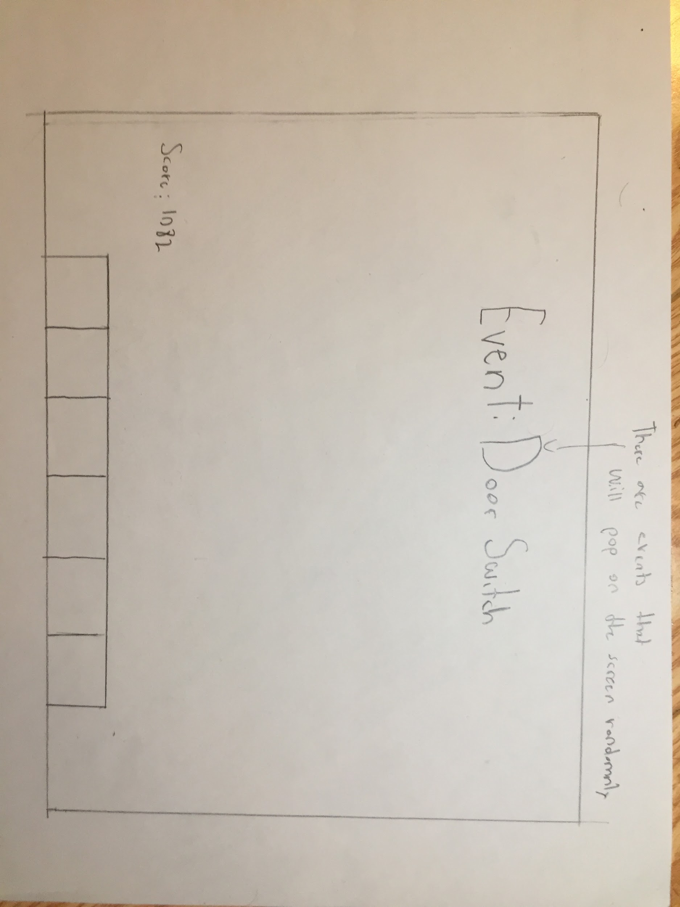

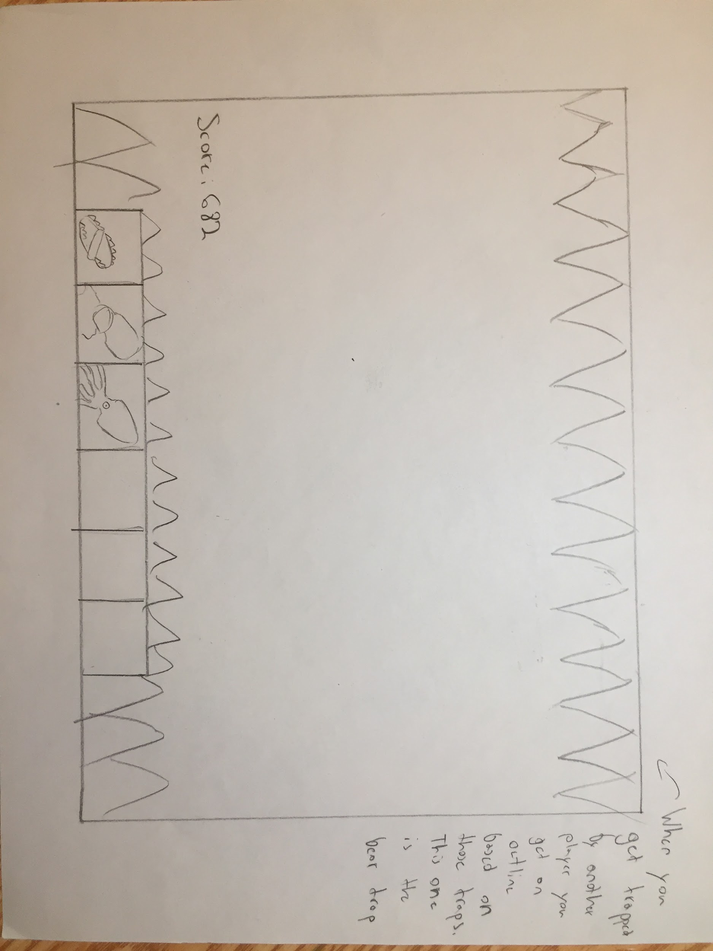

# 

# Assets Needed

## - Description of Artistic Style

### - Naming Convention

- Item naming: Location_Type(object,light,carpet)_Size/Door_ItemType_Gen_#

- Example: Floor_Object_Medium_Couch_Atomic_1

- Socket naming: Size/Door_ItemName

- Example: M_Couch

* If it’s loot, just name it “Loot”

### Item Size Categories System pitch

* XS: anything that can fit on the socket of another item, ie box of tissues on desk.
* S: Anything less than 100cm x 100cm (ie end table, small fridge, counter unit)
* M: Between 101cm x 101cm and 200cm x 200cm (ie desk, couch or bed)
* L: Larger than 201cm x 201cm but smaller than 300cm x 300cm (ie L couch, dining booth or dining/island set)

## - 2D

### - UI/HUD Display:

- Things to be included:

- Outer red tinge for chase

- Score on screen

- Inventory bar (6 items max?)

- Trap icons

- Trap screen effects (bear trap = teeth, smoke = blurred, etc)

* Keep in mind Tilan wants a pretty UI, so we might need to add some Wolfenstein-esque additive details like a lower HUD with a status bar or something.
* Wireframe/Mockup:

## - 3D

- Rooms are more or less in order of importance

### - Characters List

- Male

- Female

### - 50s Living Room Items (Atomic Age)

Room Layout: (image goes here)

- Couch

- Side table (with radio)

- Living Chair

- Shelf

- Bookcase (Books, vinyl)

- Clock

- Mantle

- House plant

- Coffee table (with rug?)

- Floor lamp (atomic themed)

- Lampshade

- TV stand

- TV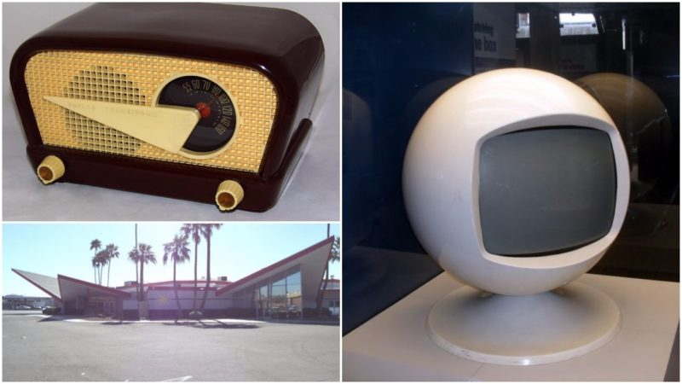

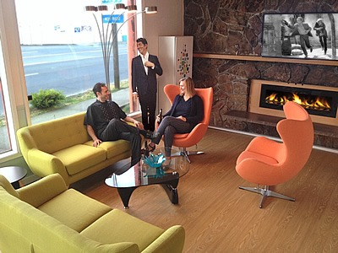

### Medieval Room

* Room Layout: (image goes here)
* Medieval Chair
* Medieval Bed
* Torch
* Sword(s)
* Cuirass
* Shield
* Mace
* Spear
* Futon

### Boy’s Bedroom

* Room Layout: (image goes here)
* Single bed
* Bunk bed [for Travis ;) ]
* Racecar bed
* Desk
* Office chair
* Bean bag chair
* Bedside table
* Bedside lamp
* Ceiling light
* Toys chest
* Computer/laptop

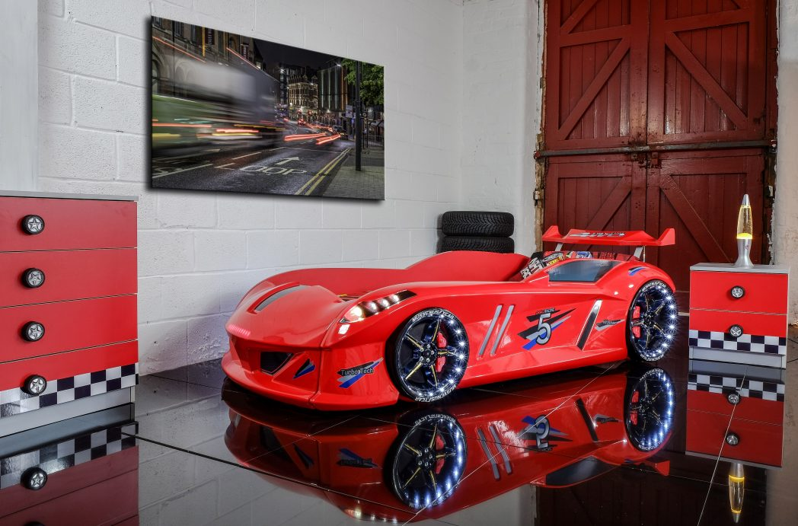

### Modern Kitchen

* Room Layout: (image goes here)
* Fridge
* Counter
* Stove and vent
* Dining table
* Dining chairs
* Counter island
* Counter island stools
* Sink
* Cupboards
* Microwave
* Ceiling light
* Blender
* Coffee machine
* Hanging lights

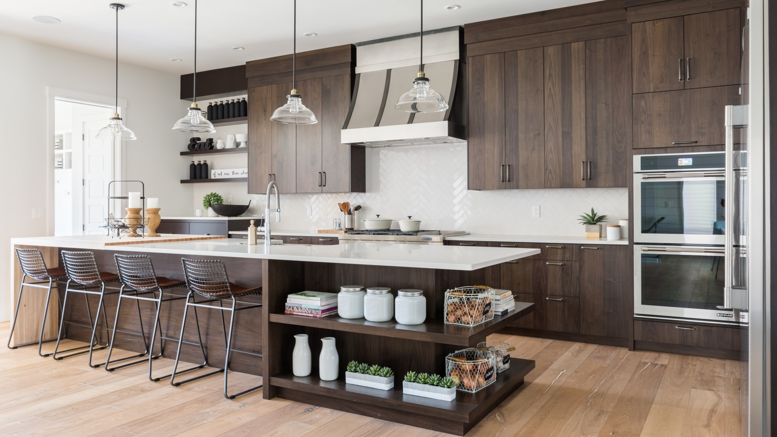

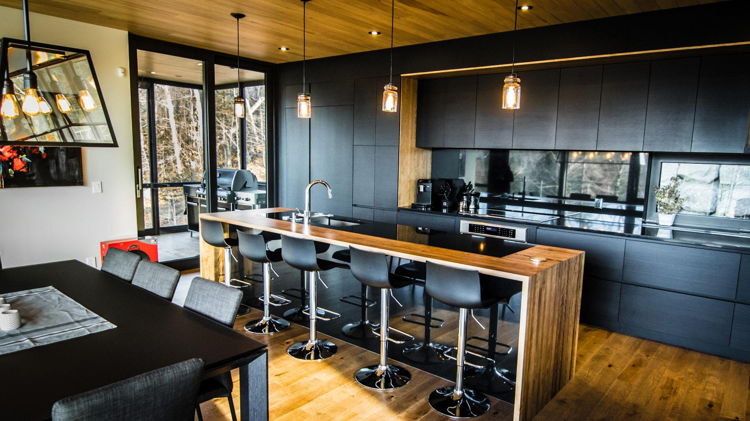

### Bathroom

* Room Layout: (image goes here)
* Toilet
* Bath
* Shower
* Sink & mirror
* Storage
* Washer & dryer

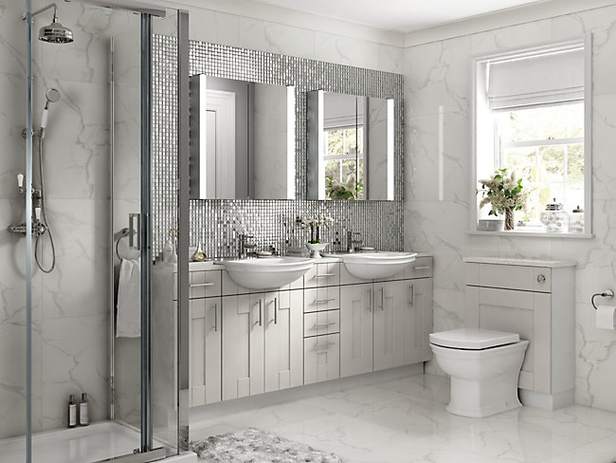

### Club Room

* Room Layout: (image goes here)
* Disco Ball
* Bar
* Bar stools
* Spotlights/stage lights
* Stripper pole (?)
* L-couches
* Bar table
* Couch table
* Booth set

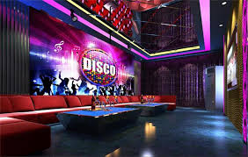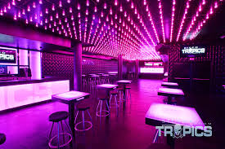

### Garden Room

* Room Layout: (image goes here)
* Plants, lots of plants
* Planter boxes
* Hanging plants
* UV lights
* Heat lamps
* Watering machine
* Plant display mechanism
* Lawn chairs

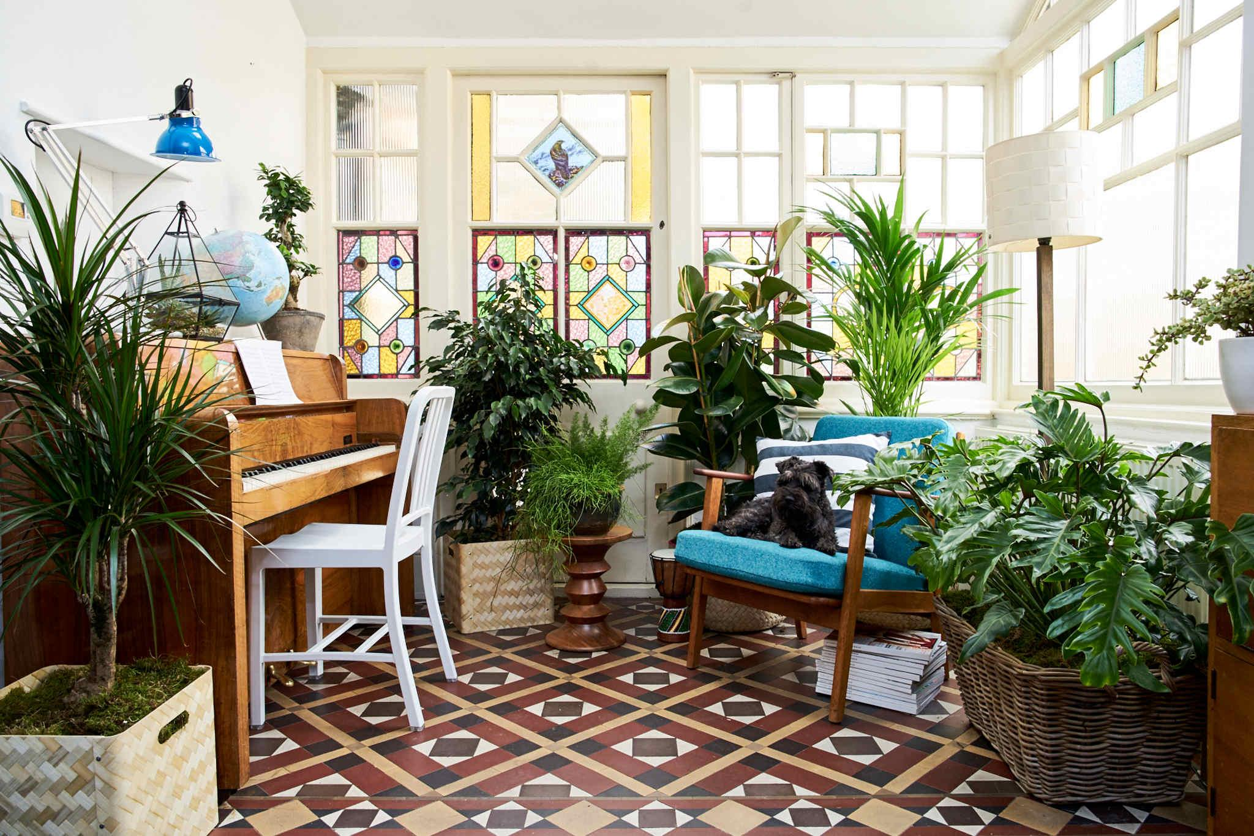

## - Sound

- Non-Gameplay List (Ambient/Music)

- Menu music

- Menu select noise

- Menu option confirm noise

- Pause noise

- Gameplay List (In-game)

- Footsteps

- Pick up object

- Gameplay music (chase theme)

- Guard alerted sound

- Time up jingle

- Caught death jingle

- Trap pickup sound

- Trap set sound

- Trap triggered sound

- Event jingle

- Loot pickup sound

## - Code

- Character Scripts (Player Pawn/Player Controller)

- Ambient Scripts (Runs in the background)

- Example

- NPC Scripts

- Example

- etc.

## - Animation

- Environment Animations

- Example

- etc.

- Character Animations

- Player

- Example

- etc.

- NPC

- Example

- etc.